SQL - Question -2

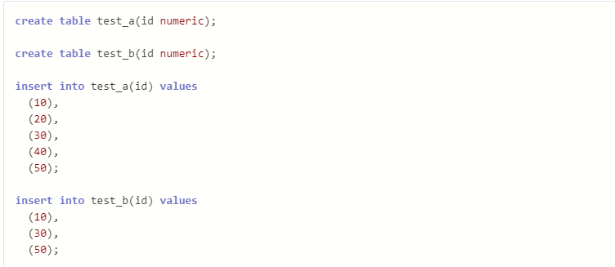

Write a query to fetch values in table test_a that are and not in test_b without using the NOT keyword.

Answer –

SELECT * FROM test_a

EXCEPT

SELECT * FROM test_b;

Alternative –

SELECT * FROM test_a

UNION ALL

SELECT * FROM test_b

MINUS

SELECT * FROM test_b;